A Branch-and-Cut Algorithm for Multiple Sequence Alignment
K. Reinert, H.-P. Lenhof, P.Muhlhorn and J.D. Kececioglu
Information Processing Letters, Vol. 41, No. 1, pp. 51-57, Jan. 1992
Proceedings of the 1st Annual International Conference on Computational Molecular Biology, pp. 241-250, 1997
Abstract
Using linear programming to solve multiple sequence alignment.

Complete Maximum Weight Trace (CMWT)
realize, trace()
complete k-partite graph
The goal is to compute an alignment of maximum weight.
Maximum Weight Trace (MWT)
Judiciously chosen subgraph of the complete k-partite graph.
alignment graph
trace polytope :(convex hull of all feasible solutions of maximum trace problem)
EAG (extended alignment graph)
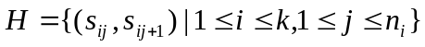
Def : mixed graph, mixed cycle, critical mixed cycle.

Thm 1 : Let G = (V,E,H) be an EAG, let TE and let G` = (V,T,H) be the EAG induced by T. Then T is a trace iff there is no critical mixed cycle in G`.

max 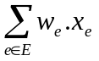 subject to 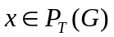

is equivalent to

maximize subject to 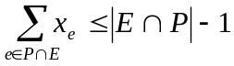 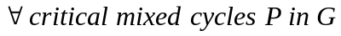
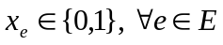
(mixed-cycle inequality)

Thm 4 : Suppose FA is a maximal clique in the k-regular independence system (A,I). Then 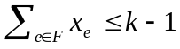 is a facet of 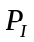
Lemma 1 : Let G=(V,E,H) be an extended alignment graph. 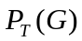 is full-dimensional and the inequalities 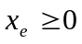, 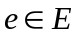 are facet-defining for . Further let be any edge in G. Then the inequality 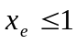 is facet-defining iff e is not contained in any critical mixed cycle of size 2.(trivial inequalities)
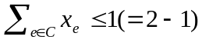, C is a maximal clique of 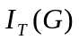 (clique inequalities)

Thm 6 : In the two sequence case the trivial and the clique inequalities together are a complete description of the trace polytope.

Def : 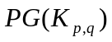

Lemma 2 : Let p=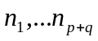 be a source to sink path in and let 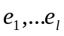, 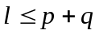 be the edges in E that correspond to essential nodes in p. Then is a clique of if 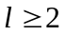. Moreover, every maximal clique of can be obtained in this way.

Thm 7: Let G be the extended alignment graph for k>2 sequences and let 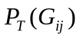 be the trace polytope for the subgraph 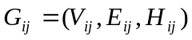 induced by the edges between the sequences 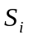 and 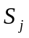,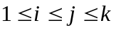. Every facet-inducing inequality of is also facet-inducing for .

Def : chord

Lemma 5 : Let 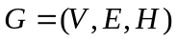 be an extended alignment graph and C be a critical mixed cycle of size . Then the inequality 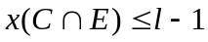 defines a facet of iff C has no chord.

Lemma 6 : Let be an extended alignment graph consisting of a critical mixed cycle C of size with a chord e. Then the inequality 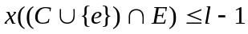 defines a facet of

Lemma 7 : Let be an extended alignment graph consisting of a critical mixed cycle C of size with n chords 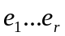, such that for each pair 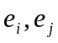,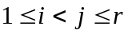, there is an edge 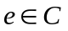that forms a mixed cycle of size3 with that pair. Then the inequality 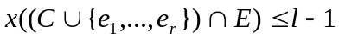 defines a facet of .

Branch-and-cut algorithm
One relaxes the given integer linear program by dropping the integer condition and solves the resulting linear program. If the solution of the linear program is integral and if all mixed cycle inequalities are satisfied then we have the optimal integral solution. Otherwise one searches for a valid inequality 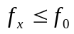 that “cuts-off” the solution , i.e., 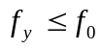 for all 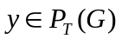 and 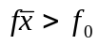; 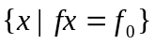 is called a cutting plane. Any cutting plane found is added to the linear program and the linear program is resolved.

Branch-and-Cut algorithm

A specific branch-and-cut algorithm for the MWT
1. How to solve the separation problem for the class of mixed-cycle inequalities.
First assign the cost 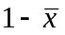 to each edge and 0 to all 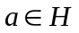. Then we compute for each node 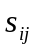,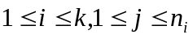 the shortest path from 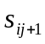 to . If there is such a shortest path P, it must contain edges from E. If the cost of P is less than 1, i.e.,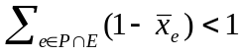, we have found a violated inequality, namely 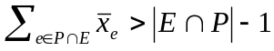, since P together with the arc 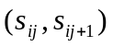 forms a mixed cycle.

- How to solve the separation problem for the class of clique inequalities.
Assume the solution of the linear program is fractional. Our problem is to find a clique C which violates the clique inequality 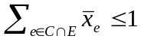. Assign the cost to each essential node 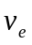 in 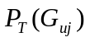. Recall that every source to sink path C with more than one essential node corresponds exactly to a clique in 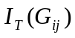. We compute the longest source to sink path C in . If the cost of C id greater than 1, i.e. 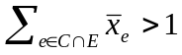 we have a violated clique inequality.
Created by : Rei-Sing Cheng
Date : Apr 9, 2002

